1 Introduction to Safe Driving | 3 Collisions and Momentum | Spring 2024
What students will figure out
- While overall trends in deaths have decreased, in recent years the number of collisions and injuries has increased.
- There are many potential causes for these trends, including distracted driving and vehicle factors and features.
- We have many questions about how distracted driving might affect the outcomes of a collision, and the effects of different vehicle factors and features
Personal Glossaries

Discussion | Crash Statistics
  - Resources
    - Slide A
  - Preview crash statistics and consider factors that affect safety

Suggested prompt | Sample student response
What do we think makes driving so dangerous? | Maybe how fast cars go now.  Yeah, sometimes cars are jacked up or modified. Maybe because they are so big now they are more dangerous or deadly?  Sometimes people are distracted, which isn’t good if you’re driving.
So what factors do you all think affects driving safety? | Speed  If the driver is paying attention.
Who or what else should we take into account? | The passengers could be impacted.  Maybe the other people on the road or the sides of the road.  People in other cars if there is a collision between two cars.  Maybe trees on the sidewalk, or animals who cross the road.

Predictions | Vehicle Safety Over Time
Resources
    - Jamboard | Things That Make Driving Safer/Less Safe
    - Slides B-D

  - Based on the graphs: notice:
    - The number of people has almost tripled over the last 100 years.
    - The number of vehicles is many times greater (over 30 times greater) now than it was over 100 years ago.
    - The ratio of people per vehicle has dropped a lot. A hundred years ago, vehicles were pretty rare in comparison to people, but now there is almost one vehicle for every person.
  - Continuing discussion, ask:
    - Do we think driving has gotten safer over time, or less safe? Why?
    - For which people/places/things that we wanted to take into account?
  - What are things that make driving safer/unsafe? Students brainstorm then assemble a list on the board
    - Some people drive too fast which is unsafe
    - People may be more distracted or not paying attention recently which is unsafe.
    - The number of cars has increased, so there may be more crashes and injuries.
    - There are more people on the road now than there used to be, so the crowded roads may be less safe.
    - We may have more people with learner's permits/provisional licenses and such than we did in the past.
    - Sometimes it can be hard to see or the roads are hazardous, which can affect safety.
    - Airbags, seatbelts, size of cars, type of car, other car factors may have made driving more safe.
  - Besides the driver, what/who else is affected by these safety variables?
    - Passengers inside the car
    - People outside the car (pedestrians, bicyclists, construction workers, other cars)
    - the environment
    - animals, plants, etc. that might be in the way of a car
  - How could we measure/quantify safety?
    - Discuss per capita statistics and the difficulty of comparing different populations and technologies
      - Statistics on people injured or killed per person, per collision, per mile, etc.

Analyzing Data | US Vehicle Fatalities
Resources
[13 minutes]
Slides E-F
US Vehicle Statistics Graphs Handout

  - Orient to the graphs (axes, scales, etc.) and explain that instructor role is to ground trends in data
  - Patterns we notice:
    - The number of deaths have generally been going down over time on both graphs.
    - Deaths per 100,000 people went up from 1920 to the mid 1930s, but then the general trend after that period has been downward.
    - Even though the “Deaths per 100,000 people '' graph fluctuates some, in general deaths have been going down over the last 90 years.
    - The 100 million vehicle miles graph decreased quickly at first, but it has leveled out in more recent years (2000s).

Analyzing Data | Trends in Injuries and Collisions
Resources
Slide G
Handout | Crashes and Injuries (paper copies; one per pair)

  - Students work in pairs:
    - Orient to the graphs. Discuss what it means to have 0.5 people injured per crash.
      - 50 injuries per 100 crashes
      - 50% of the people in a crash get injured
      - 1 person injured every 2 crashes
    - Do the data support our predictions based on the changes since 1921?
    - On paper handouts, color or draw trendlines in the data
      - Rough sketch the trendlines in lab notebooks for later reference
      - Add colored trendlines in data
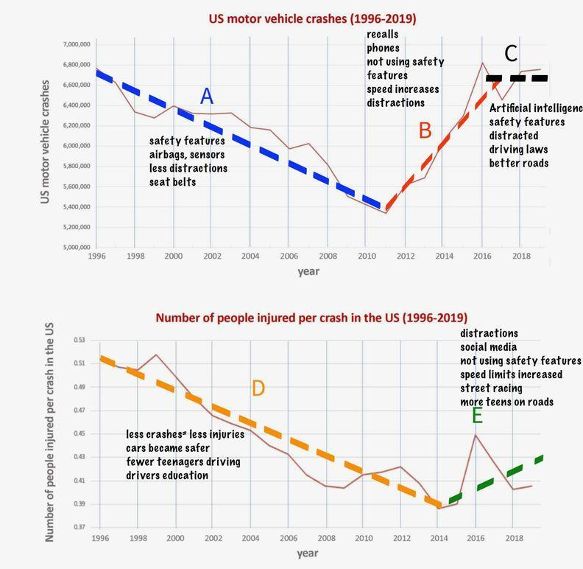

Discussion | Brainstorming Reasons for Trends
Resources
Slide G
Handout | Crashes and Injuries (paper copies; one per pair)
  - Brainstorming causes for each trend
    - Divide the class into a number of groups corresponding to the number of trendlines identified in the data
    - Each group then produces explanations for the trends observed over the time period
  - Draw out ideas about distracted driving: why have accidents and injuries increased in the decades? Are people more distracted behind the wheel now than they used to be?

Claims | Initial Claims about Distracted Driving
Resources
Slide J
Lab Notebooks
  - Have students brainstorm initial claims (in notebooks)
    - Could distracted driving affect the severity of a collision?
    - Could distracted driving contribute to an increase in crashes?
  - Compare with a partner - does your partner agree with your initial claims?

Modeling | Comparing Collisions
Resources
Slide K
2 Toy Cars (per group of 2)
Collision Scenario Sheets
10 strips of paper
Notebook paper
  - Students work with partners
    - Distribute toy cars . Have students simulate each scenario in different distracted and non-distracted situations
      - What differences, if any, do you see between the behavior of the vehicle and person in the first versus second scenario?
      - Does the type of crash affect the outcome?
      - What parts of the system are contributing to the severity of the crash? What changes in the two-car system might lead to the increase in crashes trend we saw in our graphs?
      - Could anything, other than distracted driving, affect the outcome of the collision?
    - Distribute and Collision Scenarios Sheets
  - Use strips of paper (4 per group) to set up the positions and orientations of both vehicles one second before collision in each of the four Scenarios

Consensus Model | Distracted Driving
Resources
Collision Scenario Handouts

  - Consensus Model | Distracted Driving
    - What is happening in all cases before the collision that affects the outcomes?
    - What is happening in all cases during the collision that affects the outcome?
Suggested prompt | Sample student response
What did you say might be happening in all the cases shown (A-D) that would help explain WHY there would be different outcomes? | There is at least one distracted driver vs. there are none.  The vehicles would be traveling at different speeds when they collide for distracted vs. non-distracted driving.  The non-distracted driver braked sooner.
Why might distracted driving affect the speed the vehicles would be traveling when they collide? | It would affect how much the vehicles brake before colliding.  There would more braking in non-distracted driving then distracted (where there might be none at all
When you say braking longer, do you mean distance? Time? | Maybe both?
But what impact would braking distance or time actually have on the cars as they are colliding? What impact would that have on the vehicles as they are colliding? | Maybe the higher the speed, the more force in the collision?  If they don’t have as much time to brake there is more energy in the system

- This model is all text: simply listing variables that impact crash severity
  - Separate into variables before a crash and during a crash that affect severity
- Which of these variables are related to distracted driving?
  - Could they increase the severity or frequency of crashes, explaining our data?
- Which of these variables are not related to distracted driving?
  - Size or weight of the vehicle(s)
  - The type of road or road conditions
  - Angle of impact
  - Age of vehicle
  - Seatbelts
  - Airbags
  - Lane assist, automatic emergency braking, or another adaptive technology
  - Materials the vehicle is made of (e.g. Plastic vs. metal)
  - Shape of the vehicle or type of vehicle (truck vs. car)

Consensus Model | Other Factors and Features7

Resources
Slide O
Annotated Diagram Sheet
Digital Handout | Other Facts and Features
We still want to understand trends in the data, and also considering ways to make vehicles safer
  - Crashes may be up, but fatality is down
    - What features of modern vehicles reduce injury/increase safety in a collision?
    - Complete Digital Handout and Annotated Diagram Sheet
    - Promote diversity in choices from the list (not all airbags/seatbelts)
  - Peer review with stickies?

Brainstorm | Functions of Safety Features
Resources
Slide P
Handout | Other Factors and Features (reference)
Model | Factors and Features (Exemplar)

  - Sort the safety features by timeline: before collision, during collision, after collision
    - Make a timeline of the following events: Before, Moment Of Contact, After Contact, Both cars stop moving
      - Create lists below, then classify each according to timeline
Before moment of Contact | At first contact | After moment of contact
Brakes  Wheel size / conditions  Road conditions  Automatic braking  Seatbelts (potentially) | What the vehicle(s) are made of  The size/mass of the vehicle  The angle /point of contact between the vehicles  Air bags  Seatbelts | Air bags  Seatbelts  What the rest of the inside of the vehicle is made of (steering wheel, dashboard, seats in back)

  - Create a concept map of the mechanisms by which major safety features operate
- DQB | Driving Question Board | Safety in Collisions

